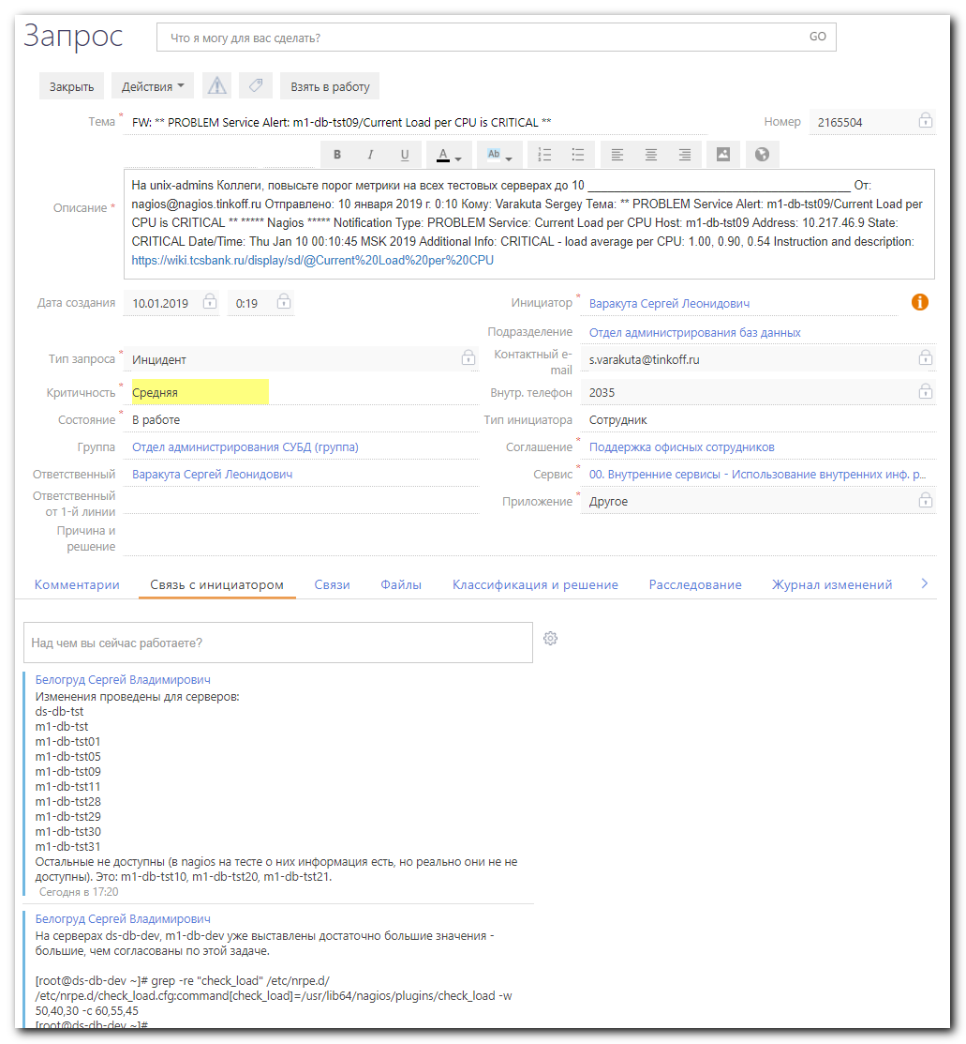

From: Chernyh Aleksandr Vladimirovich
Sent: Monday, January 14, 2019 11:58 AM
To: Belogrud Sergey Vladimirovich <s.belogrud@tinkoff.ru>; Aleksandrov Aleksey Valerievich <a.v.aleksandrov@tinkoff.ru>
Cc: unix-admins <unix-admins@tinkoff.ru>
Subject: RE: Изменение пороговых значений для Current Load per CPU в конфигурации мониторинга на тестовых db серверах по SD2165504

Добрый день, Сергей !

git@vm-gitlab01.tcsbank.ru:jet/ansible.git

nrpe.yml

+unix-admins, вдруг кто-то из коллег ещё не в курсе местоположения

Александр Черных
Главный Системный Администратор

From: Belogrud Sergey Vladimirovich
Sent: Monday, January 14, 2019 11:51 AM
To: Aleksandrov Aleksey Valerievich <a.v.aleksandrov@tinkoff.ru>
Cc: Chernyh Aleksandr Vladimirovich <a.chernyh@tinkoff.ru>
Subject: Изменение пороговых значений для Current Load per CPU в конфигурации мониторинга на тестовых db серверах по SD2165504

Добрый день.

Коллеги, подскажите чем распространяются настройки конфигурационных файлов для nagios-мониторинга на тестовые db-серверы?
По SD2165504 требуется изменить пороговые значения проверки check_load. Нужно поменять настройки в yml-сценарии, который применяется для этой настройки. Нужно знать место расположения этого yml-файла.
Если это делается всё иначе - то как?

[root@vm-vol-nag4-tst objects]# vim -R /usr/local/nagios/etc/objects/services/db-tst-global-service.cfg
…
define service{
use generic-service-current-load
host_name .*-db-tst(0[5-9]|1[0-9]|2[0-9]|3[0-9])$
service_description Current Load per CPU
contact_groups linux-admins,oracle-admins
check_command check_nrpe!check_load
}
…

Текущий кофиг следующий:
[root@m1-db-tst09 ~]# grep -re "check_load" /etc/nrpe.d/nrpe_ansible.cfg
command[check_load]=/usr/lib64/nagios/plugins/check_load -r -w 0.8,0.8,0.8 -c 10,10,10
[root@m1-db-tst09 ~]#

С уважением,

Сергей Белогруд
Старший системный администратор

# Direct link to repository is: https://vm-gitlab01.tcsbank.ru/jet/ansible
#
#
# I’ve tried to make change in yaml playbook nrpe.yml, but it was too much difficult and it was unsuccessful.
# Much better and faster way became a way to select - what task to apply.
#

#
# I’ve made two clones of target repository. One under virtualbox to apply changes on servers. The second in MobaXterm - to commit and push changes.
# I think, it’s possible to use only one clone, placed into c:/share folder - it will be available from virtualbox and from MobaXterm.
#

# I’ve attempted to use --tags to apply only one task, but it wouldn’t work for this case...
[support@centos ansible]$ ansible-playbook nrpe.yml -i list_of_hosts --become --extra-vars "ansible_user=bsv ansible_password=$(pass common/linux) ansible_sudo_pass=$(pass common/linux) ansible_ssh_common_args='-oStrictHostKeyChecking=no -oPubkeyAuthentication=no'" --tags "Create nrpe_ansible.cfg from template" --check

...........................................................................

[support@centos ansible]$ pwd
/home/support/work/20190114-1612/ansible
[support@centos ansible]$
[support@centos ansible]$ git clone git@vm-gitlab01.tcsbank.ru:jet/ansible.git

[support@centos ansible]$ ansible-playbook nrpe.yml -i list_of_hosts --become --extra-vars "ansible_user=bsv ansible_password=$(pass common/linux) ansible_sudo_pass=$(pass common/linux) ansible_ssh_common_args='-oStrictHostKeyChecking=no -oPubkeyAuthentication=no'" --step --check

PLAY [all] *******************************************************************************************************************************************************************************************
Perform task: TASK: Gathering Facts (N)o/(y)es/(c)ontinue: y

Perform task: TASK: Gathering Facts (N)o/(y)es/(c)ontinue: *******************************************************************************************************************************************

TASK [Gathering Facts] *******************************************************************************************************************************************************************************
ok: [m1-db-tst28]
ok: [m1-db-tst29]
ok: [m1-db-tst11]
ok: [m1-db-tst30]
ok: [m1-db-tst31]
ok: [m1-db-tst05]
ok: [m1-db-tst01]
ok: [ds-db-tst]
ok: [m1-db-tst]
Perform task: TASK: nagios-nrpe-server : Include OS-Specific variables (N)o/(y)es/(c)ontinue: y

Perform task: TASK: nagios-nrpe-server : Include OS-Specific variables (N)o/(y)es/(c)ontinue: ********************************************************************************************************

TASK [nagios-nrpe-server : Include OS-Specific variables] ********************************************************************************************************************************************
ok: [m1-db-tst05]
ok: [m1-db-tst01]
ok: [m1-db-tst11]
ok: [m1-db-tst28]
ok: [m1-db-tst29]
ok: [m1-db-tst31]
ok: [m1-db-tst30]
ok: [ds-db-tst]
ok: [m1-db-tst]
Perform task: TASK: nagios-nrpe-server : Include RedHat architecture specific variables (N)o/(y)es/(c)ontinue: y

Perform task: TASK: nagios-nrpe-server : Include RedHat architecture specific variables (N)o/(y)es/(c)ontinue: ***************************************************************************************

TASK [nagios-nrpe-server : Include RedHat architecture specific variables] ***************************************************************************************************************************
[WARNING]: when statements should not include jinja2 templating delimiters such as {{ }} or {% %}. Found: '{{ ansible_os_family }}' == 'RedHat'

[WARNING]: when statements should not include jinja2 templating delimiters such as {{ }} or {% %}. Found: '{{ ansible_os_family }}' == 'RedHat'

[WARNING]: when statements should not include jinja2 templating delimiters such as {{ }} or {% %}. Found: '{{ ansible_os_family }}' == 'RedHat'

[WARNING]: when statements should not include jinja2 templating delimiters such as {{ }} or {% %}. Found: '{{ ansible_os_family }}' == 'RedHat'

[WARNING]: when statements should not include jinja2 templating delimiters such as {{ }} or {% %}. Found: '{{ ansible_os_family }}' == 'RedHat'

[WARNING]: when statements should not include jinja2 templating delimiters such as {{ }} or {% %}. Found: '{{ ansible_os_family }}' == 'RedHat'

[WARNING]: when statements should not include jinja2 templating delimiters such as {{ }} or {% %}. Found: '{{ ansible_os_family }}' == 'RedHat'

[WARNING]: when statements should not include jinja2 templating delimiters such as {{ }} or {% %}. Found: '{{ ansible_os_family }}' == 'RedHat'

ok: [m1-db-tst05]
ok: [m1-db-tst01]
ok: [m1-db-tst11]
ok: [m1-db-tst28]
ok: [m1-db-tst29]
ok: [m1-db-tst31]
ok: [m1-db-tst30]
ok: [ds-db-tst]
[WARNING]: when statements should not include jinja2 templating delimiters such as {{ }} or {% %}. Found: '{{ ansible_os_family }}' == 'RedHat'

ok: [m1-db-tst]
Perform task: TASK: nagios-nrpe-server : include (N)o/(y)es/(c)ontinue: N

Perform task: TASK: nagios-nrpe-server : include (N)o/(y)es/(c)ontinue: ******************************************************************************************************************************
Perform task: TASK: nagios-nrpe-server : Create nrpe.cfg from template (N)o/(y)es/(c)ontinue: N

Perform task: TASK: nagios-nrpe-server : Create nrpe.cfg from template (N)o/(y)es/(c)ontinue: ********************************************************************************************************
Perform task: TASK: nagios-nrpe-server : Create nrpe_ansible.cfg from template (N)o/(y)es/(c)ontinue: y

Perform task: TASK: nagios-nrpe-server : Create nrpe_ansible.cfg from template (N)o/(y)es/(c)ontinue: ************************************************************************************************

TASK [nagios-nrpe-server : Create nrpe_ansible.cfg from template] ************************************************************************************************************************************
changed: [m1-db-tst11]
changed: [m1-db-tst28]
changed: [m1-db-tst01]
changed: [m1-db-tst05]
changed: [m1-db-tst29]
changed: [m1-db-tst30]
changed: [m1-db-tst31]
changed: [ds-db-tst]
changed: [m1-db-tst]
Perform task: TASK: nagios-nrpe-server : Install global plugins (N)o/(y)es/(c)ontinue: N

Perform task: TASK: nagios-nrpe-server : Install global plugins (N)o/(y)es/(c)ontinue: ***************************************************************************************************************
Perform task: TASK: nagios-nrpe-server : Install goss plugin (N)o/(y)es/(c)ontinue: N

Perform task: TASK: nagios-nrpe-server : Install goss plugin (N)o/(y)es/(c)ontinue: ******************************************************************************************************************
Perform task: TASK: nagios-nrpe-server : Install goss plugin (N)o/(y)es/(c)ontinue: N

Perform task: TASK: nagios-nrpe-server : Install goss plugin (N)o/(y)es/(c)ontinue: ******************************************************************************************************************
Perform task: TASK: nagios-nrpe-server : Install per-server plugins (N)o/(y)es/(c)ontinue: N

Perform task: TASK: nagios-nrpe-server : Install per-server plugins (N)o/(y)es/(c)ontinue: ***********************************************************************************************************
Perform task: TASK: nagios-nrpe-server : Configure sudoers (N)o/(y)es/(c)ontinue: N

Perform task: TASK: nagios-nrpe-server : Configure sudoers (N)o/(y)es/(c)ontinue: ********************************************************************************************************************
Perform task: TASK: nagios-nrpe-server : Ensure NRPE server is running (N)o/(y)es/(c)ontinue: N

Perform task: TASK: nagios-nrpe-server : Ensure NRPE server is running (N)o/(y)es/(c)ontinue: ********************************************************************************************************

RUNNING HANDLER [nagios-nrpe-server : restart nagios-nrpe-server] ************************************************************************************************************************************
changed: [m1-db-tst28]
changed: [m1-db-tst29]
changed: [m1-db-tst11]
changed: [m1-db-tst05]
changed: [m1-db-tst01]
changed: [m1-db-tst30]
changed: [m1-db-tst31]
changed: [m1-db-tst]
changed: [ds-db-tst]

PLAY RECAP *******************************************************************************************************************************************************************************************
ds-db-tst : ok=5 changed=2 unreachable=0 failed=0
m1-db-tst : ok=5 changed=2 unreachable=0 failed=0
m1-db-tst01 : ok=5 changed=2 unreachable=0 failed=0
m1-db-tst05 : ok=5 changed=2 unreachable=0 failed=0
m1-db-tst11 : ok=5 changed=2 unreachable=0 failed=0
m1-db-tst28 : ok=5 changed=2 unreachable=0 failed=0
m1-db-tst29 : ok=5 changed=2 unreachable=0 failed=0
m1-db-tst30 : ok=5 changed=2 unreachable=0 failed=0
m1-db-tst31 : ok=5 changed=2 unreachable=0 failed=0

[support@centos ansible]$

...........................................................................

[s.belogrud@TCS4357]# git status
On branch master
Your branch is up-to-date with 'origin/master'.
Changes not staged for commit:
(use "git add <file>..." to update what will be committed)
(use "git checkout -- <file>..." to discard changes in working directory)

modified: nrpe.yml

no changes added to commit (use "git add" and/or "git commit -a")
[s.belogrud@TCS4357]# git commit --author='Sergey Belogrud <s.belogrud@tinkoff.ru>' -m "SD#2165504" nrpe.yml
[master d7e3555] SD#2165504
Author: Sergey Belogrud <s.belogrud@tinkoff.ru>
1 file changed, 1 insertion(+), 1 deletion(-)
[s.belogrud@TCS4357]# git push origin master
Counting objects: 3, done.
Delta compression using up to 8 threads.
Compressing objects: 100% (3/3), done.
Writing objects: 100% (3/3), 337 bytes | 0 bytes/s, done.
Total 3 (delta 2), reused 0 (delta 0)
To git@vm-gitlab01.tcsbank.ru:jet/ansible.git
340e188..d7e3555 master -> master
[s.belogrud@TCS4357]#

...........................................................................

#
# To be able to make commit, I’ve added myself as a maintainer.
#
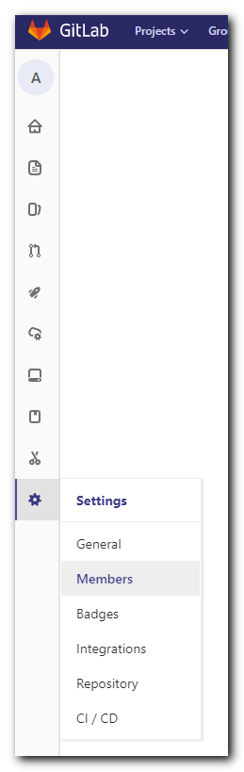
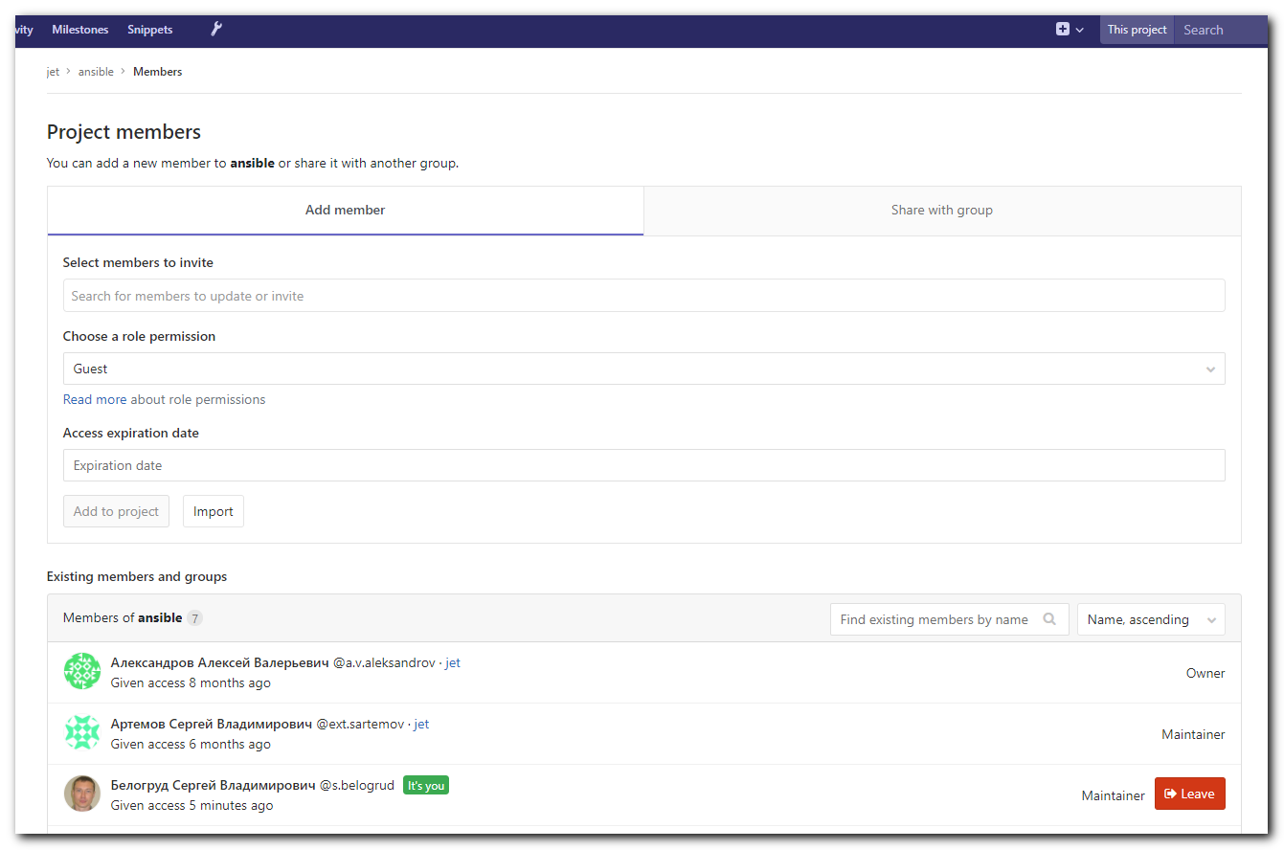

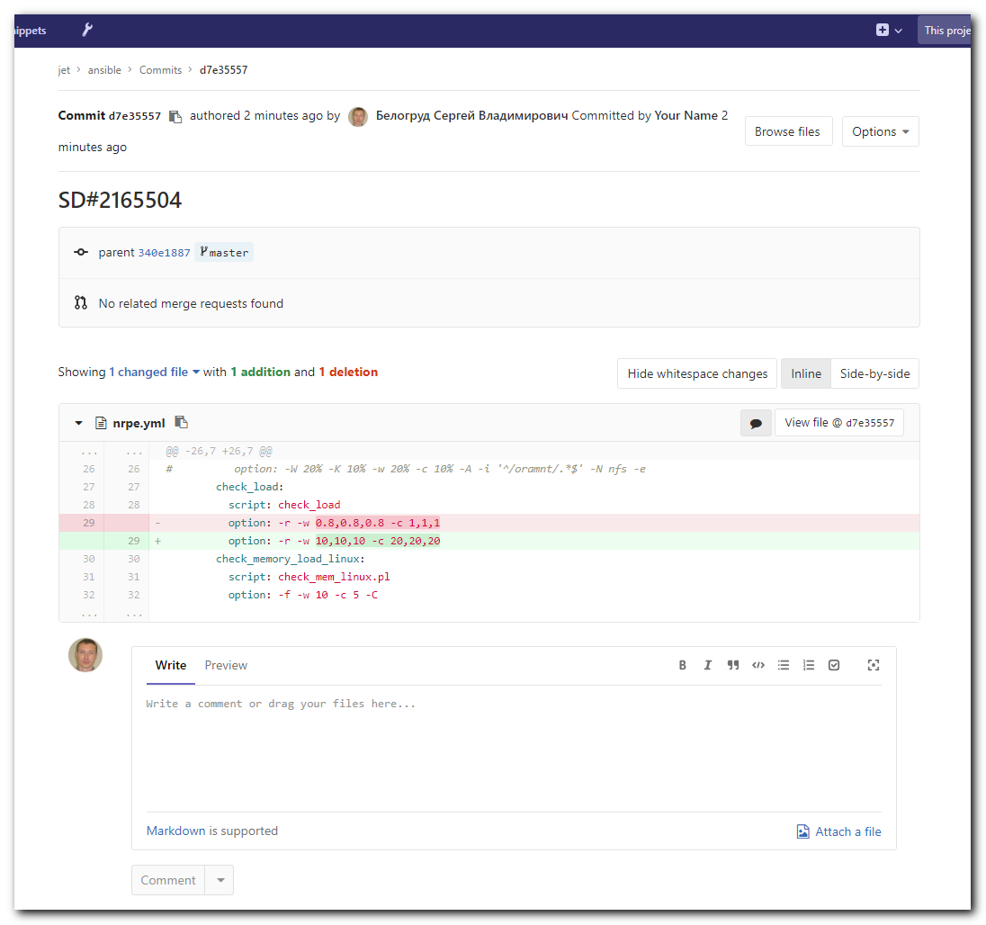

https://stackoverflow.com/questions/23945201/how-to-run-only-one-task-in-ansible-playbook

